### EVERENT

**A PROJECT REPORT**

***Submitted by***

**YOGA NARASIMMAN S 727822TUAM063**

***in partial fulfillment for the award of the degree of***

### BACHELOR OF ENGINEERING

### IN

**DEPARTMENT OF ARTIFICIAL INTELLIGENCE AND MACHINE LEARNING**

### FEBUARY 2023

**BONAFIDE CERTIFICATE**

Certified that this project report **“EVERENT”** is the bonafide work of

### “YOGA NARASIMMAN S” who carried out the project work under my

### supervision.

#### SIGNATURE SIGNATURE

**Ms.M.KAVITHA MARGRET Dr.T.RAJESH KUMAR**

#### SUPERVISOR HEAD OF THE DEPARTMENT

Assistant Professor, Associate Professor,

Department of Computer Science Department of Artificial Intelligence

and Engineering and Machine Learning

Sri Krishna College of Technology Sri Krishna College of Technology,

Coimbatore-641042. Coimbatore-641042.

Certified that the candidates were examined by us in the Project Work Viva

Voce examination held on at Sri Krishna College of Technology,

Kovaipudur, Coimbatore -641042

### INTERNAL EXAMINER EXTERNAL EXAMINER

iii

### ACKNOWLEDGEMENT

First and foremost, I thank the **Almighty** for being our light and for showering his gracious blessings throughout the course of this project.

I am grateful to our beloved Dean-Academics **Dr.Manju P and** Dean-Administration **Dr.R.Ramesh Kumar** for their tireless and relentless support.

I extend our sincere thanks to our Head of the Department

**Dr.T.Rajesh Kumar** for her encouragement and inspiration.

I am greatly indebted to our Industry Mentor **Ms.Karthika** and Project guide **Ms.M.Kavitha Margret** Assistant Professor, Department of Computer Science and Engineering for their valuable guidance and suggestions in all aspects that aided us to ameliorate our skills.

I am thankful to all those who have directly and indirectly extended their help to us in completing this project work successfully.

iv

## ABSRACT

Everent is a cutting-edge online platform for renting various items, ranging from household goods, electronics, tools and equipment, party supplies, and more. The platform connects renters with owners of underutilized assets, providing a seamless and convenient way to rent what you need, when you need it.The website offers an easy-to-use interface that enables users to search for and find the specific items they need, view detailed product descriptions and images, and rent the items for a predetermined period of time. Renters can also securely pay for the items online, eliminating the need for in-person transactions.The owners of the assets benefit from Everent by being able to monetize their underutilized assets and recoup some of the costs associated with purchasing them. They can list their items on the platform, set the rental price, and manage the rental process, all from the comfort of their own home.Everent takes great care to ensure that all transactions are secure and that both renters and owners have a positive experience. The platform implements rigorous screening procedures for both parties and provides clear and concise rental agreements, dispute resolution processes, and insurance options to mitigate potential risks.In summary, Everent offers a convenient and efficient way for renters to access the items they need, and for owners to monetize their underutilized assets. Whether you're looking to rent a specific item for a short period of time or you're an owner looking to generate additional income from your unused assets, Everent is the perfect solution.

vii

**TABLE OF CONTENT**

|  |  |  |
| --- | --- | --- |
| **CHAPTER.NO** | **TITLE**  ABSTRACT  LIST OF FIGURES  LIST OF ABBREVIATIONS | **PAGE NO**  iv  v  vi |
| 1 | INTRODUCTION | 1 |
|  | 1.1 OVERVIEW | 2 |
|  | 1.2 OBJECTIVE | 2 |
| 2 | SYSTEM SPECIFICATIONS  2.1 VS CODE  2.2 LOCAL STORAGE  2.3 HTML  2.4 CSS  2.5 JAVA SCRIPT | 3  3  4  5  5  6 |
| 3 | METHODOLOGIES | 7 |
|  | 3.1 HOME PAGE | 8 |
|  | 3.2 CATEGORIES PAGE | 9 |
|  | 3.3 SIGNIN PAGE | 10 |
|  | 3.4 SETTINGS PAGE | 11 |
|  | 3.5 ABOUT PAGE | 13 |
| 4 | IMPLEMENTATION AND RESULT | 14 |
| 5 | CONCLUSION AND FUTURE SCOPE | 31 |
|  | 5.1 CONCLUSION | 31 |
|  | 5.2 FUTURE SCOPE | 31 |
|  | 5.3 REFERENCES | 32 |

v

**LIST OF FIGURES**

|  |  |  |
| --- | --- | --- |
| **Figure No** | **TITLE** | **Page No** |
| 3.0 | Process flow diagram | 7 |
| 3.1 | Home page flowchart | 8 |
| 3.2 | Categories page flowchart | 9 |
| 3.3 | Signin page flowchart | 10 |
| 3.4 | Settings page flowchart | 10 |
| 3.5 | About page flowchart | 13 |
|  |  |  |
|  |  |  |
|  |  |  |
|  |  |  |
|  |  |  |

vi

### LIST OF ABBREVIATIONS

#### ABBREVIATIONS

**ACRONYMS**

**HTML** HYPERTEXT MARKUP LANGUAGE

**CSS** CASCADING STYLESHEET

**JS** JAVASCRIPT

1

## CHAPTER 1 INTRODUCTON

Everent is an innovative and user-friendly platform that offers a wide range of rental options for consumers, businesses, and organizations. This online marketplace connects renters with owners of underutilized assets, providing a convenient and cost-effective solution for accessing the things you need, when you need them.

With Everent, you can rent anything from household goods, electronics, tools and equipment, party supplies, and more. The platform's intuitive interface makes it easy to search for and find the specific items you need, with detailed product descriptions and images to help you make an informed decision. Renting items is simple, too - just select the items you need, specify the rental period, and make payment online.

For owners, Everent is a fantastic way to monetize your underutilized assets and recoup some of the costs associated with purchasing them. Whether it's a high-end camera that you only use a few times a year, or an expensive tool set that's gathering dust in the garage, you can list your items on Everent and earn income from them when they're not in use.

Everent takes great care to ensure that all transactions are secure and that both renters and owners have a positive experience. The platform implements strict screening procedures for both parties and provides clear and concise rental agreements, dispute resolution processes, and insurance options to mitigate potential risks. Additionally, the platform's secure payment system makes it easy to pay for and manage rentals, and its comprehensive support resources are always available to help you get the most out of your experience.

Whether you're looking to rent an item for a specific project, or you're an owner looking to earn income from your unused assets, Everent has got you covered. With its wide range of rental options, flexible rental periods, and secure, streamlined process, it's the perfect solution for anyone looking to access the things they need, when they need them.

So why wait? Sign up for Everent today and start enjoying the benefits of this revolutionary platform! With its extensive inventory, user-friendly interface, and comprehensive support resources, you're sure to find exactly what you're looking for.

2

### OVERVIEW

Everent is an online rental platform that connects renters with owners of underutilized assets. It provides a convenient and cost-effective solution for accessing items like household goods, electronics, tools and equipment, party supplies, and more. Renters can easily search for and find the specific items they need, view detailed product descriptions and images, and rent the items for a predetermined period of time, all from the comfort of their own home. Owners can list their items on the platform, set the rental price, and manage the rental process, allowing them to monetize their underutilized assets and generate additional income. Everent implements strict screening procedures and provides clear and concise rental agreements, dispute resolution processes, and insurance options to ensure a positive experience for both renters and owners..

### OBJECTIVE

The primary objective of Everent is to provide a platform for renters to access the items they need, when they need them, and for owners to monetize their underutilized assets. The platform aims to eliminate the need for renters to purchase items they may only use a few times, and to provide owners with an easy and efficient way to earn income from their unused assets.

Everent also strives to create a secure and user-friendly environment where both renters and owners can have a positive experience. The platform implements rigorous screening procedures and provides clear rental agreements, dispute resolution processes, and insurance options to ensure a safe and reliable rental experience.

In short, the objective of Everent is to provide a convenient and cost-effective way for renters to access the items they need, and for owners to monetize their underutilized assets, while promoting sustainability and creating a secure and user-friendly environment.

## CHAPTER 2

3

## SYSTEM SPECIFICATION

In this chapter, I are gonna see the softwares that I have used to build the website. This chapter gives you a small description about the softwares used in the project.

### 2.1 VS CODE

Visual Studio Code is a source code editor developed by Microsoft for Windows, Linux, and macOS. It includes support for debugging, embedded Git control, syntax highlighting, intelligent code completion, snippets, and code refactoring. It is also customizable, so users can change the editor's theme, keyboard shortcuts, and preferences.

VS Code is an excellent code editor for React projects. It is lightweight, customizable, and has a wide range of features that make it ideal for React development. It has built-in support for JavaScript, JSX, and TypeScript, and enables developers to quickly move between files and view detailed type definitions. It also has a built-in terminal for running tasks. Additionally, VS Code has an extensive library of extensions that allow developers to quickly add features like code snippets, debugging tools, and linting support to their projects.

### LOCAL STORAGE

Local storage is a type of web storage for storing data on the client side of a web browser. It allows websites to store data on a user’s computer, which can then be accessed by the website again when the user returns. Local storage is a more secure alternative to cookies because it allows websites to store data without having to send it back and forth with each request. Local storage is a key-value pair storage mechanism, meaning it stores data in the form of a key and corresponding value.

It is similar to a database table in that it stores data in columns and rows, except that local storage stores the data in the browser rather than in a database. Local storage is often used to store user information such as preferences and settings, or to store data that is not meant to be shared with other websites. It is also used to cache data to improve the performance of a website. Local storage is supported by all modern web browsers, including Chrome,Firefox, Safari, and Edge. It is accessible through the browser’s JavaScript API. Local storage is a powerful tool for websites to store data on the client side. It is secure, efficient, and can be used to store data that does not need to be shared with other websites.

4

Local Storage is a great way to improve the performance of a website by caching data. Local storage in web browsers allows website data to be stored locally on the user’s computer. It is a way of persistently storing data on the client side, which is not sent to the server with each request. This allows users to store data such as preferences, login information, and form data without needing to send it to a server. It is typically stored in a browser’s cookie file, but it can also be stored in other locations such as HTML5 Local Storage and IndexedDB. The data stored in local storage is persistent and can be accessed by the website even if the user closes the browser or navigates to another page. It is a great way for websites to store user-specific data, as it is secure, reliable, and fast. It is also a great way for developers to store data that does not need to be sent to the server with each request.

One of the key benefits of using local storage is its reliability. Unlike server-side storage, which can be affected by network outages or other server issues, local storage is stored locally on the user’s machine, and so is not affected by these issues. Another advantage of local storage is its speed. Because the data is stored locally, it is accessed quickly, as there is no need to send requests to a server. This makes it ideal for storing data that needs to be accessed quickly, such as user preferences or session data.

5

Local storage is also secure, as the data is stored on the user’s machine and not on a server. This means that the data is not accessible by anyone other than the user, making it a good choice for storing sensitive information.

**2.3 HTML**

The HyperText Markup Language or HTML is the standard markup language for documents designed to be displayed in a web browser. It can be assisted by technologies such as Cascading Style Sheets (CSS) and scripting languages such as JavaScript.

Web browsers receive HTML documents from a web server or from local storage and render the documents into multimedia web pages. HTML describes the structure of a web page semantically and originally included cues for the appearance of the document.

HTML elements are the building blocks of HTML pages. With HTML constructs, images and other objects such as interactive forms may be embedded into the rendered page. HTML provides a means to create structured documents by denoting structural semantics for text such as headings, paragraphs, lists, links, quotes, and other items. HTML elements are delineated by tags, written using angle brackets.

**2.4 CSS**

Cascading Style Sheets (CSS) is a style sheet language used for describing the presentation of a document written in a markup language such as HTML or XML (including XML dialects such as SVG, MathML or XHTML). CSS is a cornerstone technology of the World Wide Web, alongside HTML and JavaScript

6

CSS is designed to enable the separation of content and presentation, including layout, colors, and fonts. This separation can improve content accessibility; provide more flexibility and control in the specification of presentation characteristics; enable multiple web pages to share formatting by specifying the relevant CSS in a separate .css file, which reduces complexity and repetition in the structural content; and enable the .css file to be cached to improve the page load speed between the pages that share the file and its formatting.

**2.5 Java Script**

JavaScript often abbreviated as JS, is a programming language that is one of the core technologies of the World Wide Web, alongside HTML and CSS.ss

JavaScript is a high-level, often just-in-time compiled language that conforms to the ECMAScript standard It has dynamic typing, prototype-based object-orientation, and first-class functions. It is multi-paradigm, supporting event-driven, functional, and imperative programming styles. It has application programming interfaces (APIs) for working with text, dates, regular expressions, standard data structures, and the Document Object Model (DOM).

## CHAPTER 3 METHODOLOGIES

7

This chapter gives a small description about how our system works.

|  |
| --- |
| ABOUT  SETTINGS  SIGNIN  CATEGORIES  HOME  WEB PAGE |

Fig 3.0 PROCESS FLOW DIAGRAM

### 3.1 HOME

8

HOME

HOME PAGE CONTENT

BACK

MAIN PAGE

Fig 3.1 HOME PAGE FLOWCHART

The home page for Everent is designed to be user-friendly and easy to navigate, providing quick access to all of the platform's key features and functions. The home page showcases the latest listings and popular categories, making it simple for renters to find the items they need. A clear call-to-action encourages users to start their rental journey by searching for items, creating an account, or listing their own assets. The home page also features a brief overview of Everent's mission, benefits, and services, as well as links to the platform's support resources and FAQs. The design is clean and minimalistic, allowing users to focus on the content and quickly find what they are looking for. The home page serves as the hub for the Everent platform and is the starting point for renters and owners to access the platform's full range of features and services.

9

### 3.2 CATEGORIES PAGE

CATEGORIES

ACCESSORIES

BACK

GYM APPLIANCES

HOME APPLIANCES

COOKING APPLIANCES

ITEMS BASED ON PAGE

MAIN PAGE

Fig 3.2 CATEGORIES PAGE FLOWCHART

### 3.3 SIGNIN PAGE

100

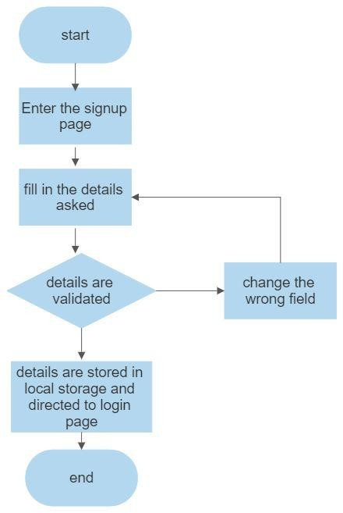

Fig 3.3 SIGNIN PAGE FLOWCHART

This page asks users about the basic details of the user to create an account. This page asks for details like username, password,email id, phone number. After the user enters the details , these details are then validated by our code . If all details are correct then the user is then directed to the login page

### 3.4 SETTINGS PAGE

11

PROFILE

NAME

NAME:

LOCATION

LOCATION:

SEX

N/A

FEMALE

MALE

REVIEW

WRITTING BOX

SAVE SETTINGS

Fig 3.4 SETTINGS PAGE FLOWCHART

SETTINGS PAGE DETAILS:

12

The settings page for an event platform like Everevent should provide users with an easy way to customize and manage their events.

A good settings page should include options to edit the basic event details such as the event name, date, time, location, and description. It should also provide a way for the user to upload a custom event logo or image.

Additionally, the settings page should include options to manage ticket types, set up registration forms, and enable different payment options. Users should also be able to configure privacy settings, such as making the event private or public, and choosing who can see the event details.

Another important feature of a good settings page is the ability to send email notifications to attendees, such as reminders or updates about the event. There should also be options to promote the event through social media, as well as a dashboard to track attendance and ticket sales.

Overall, the settings page for an event platform should provide users with all the necessary tools to effectively manage and promote their events.

13

### 3.5 ABOUT PAGE

ABOUT

CONTENT

LINKED WITH EMAIL AND INSTAGRAM

BACK

Fig 3.5 ABOUT PAGE FLOWCHART

An effective About page should be well-designed and easy to navigate, highlighting the history, key people, and achievements of the organization. It should also include a clear explanation of the organization's purpose and goals, as well as its approach to delivering products or services.

Including testimonials, customer reviews, and media mentions can help build trust and credibility with potential customers. Highlighting awards, certifications, or accreditations can also help demonstrate the organization's expertise and success.

In addition to showcasing the organization, an About page should also provide a platform for the audience to connect with the business. This can include a contact form, email address, or social media links.

Overall, an About page is an opportunity for a business or organization to showcase their unique qualities, build trust with their audience, and establish a strong online presence.

**CHAPTER 4**

**IMPLEMENTATION AND RESULT**

This chapter gives a description about the output that I produced by developing the website of our idea.

### 4.1 HOME

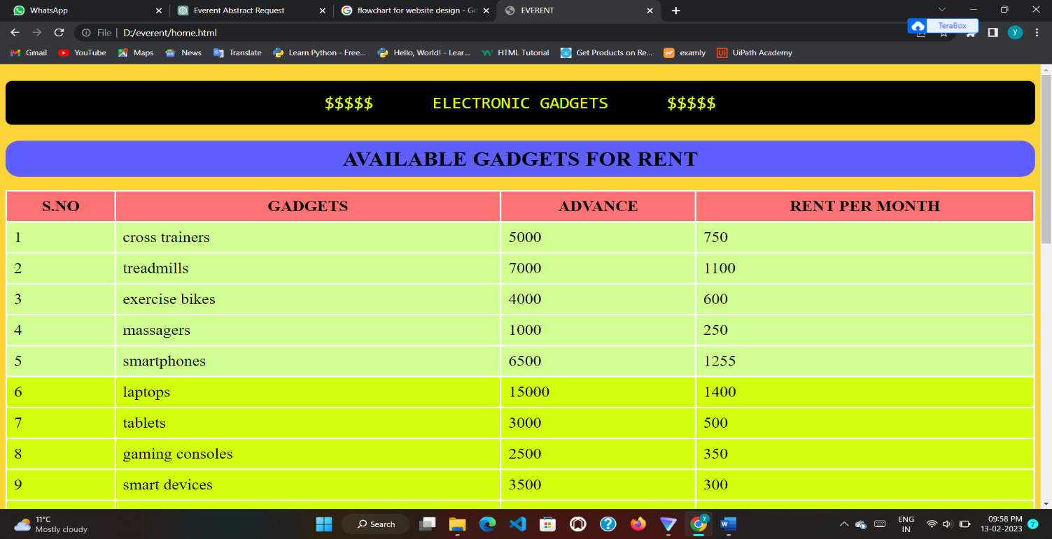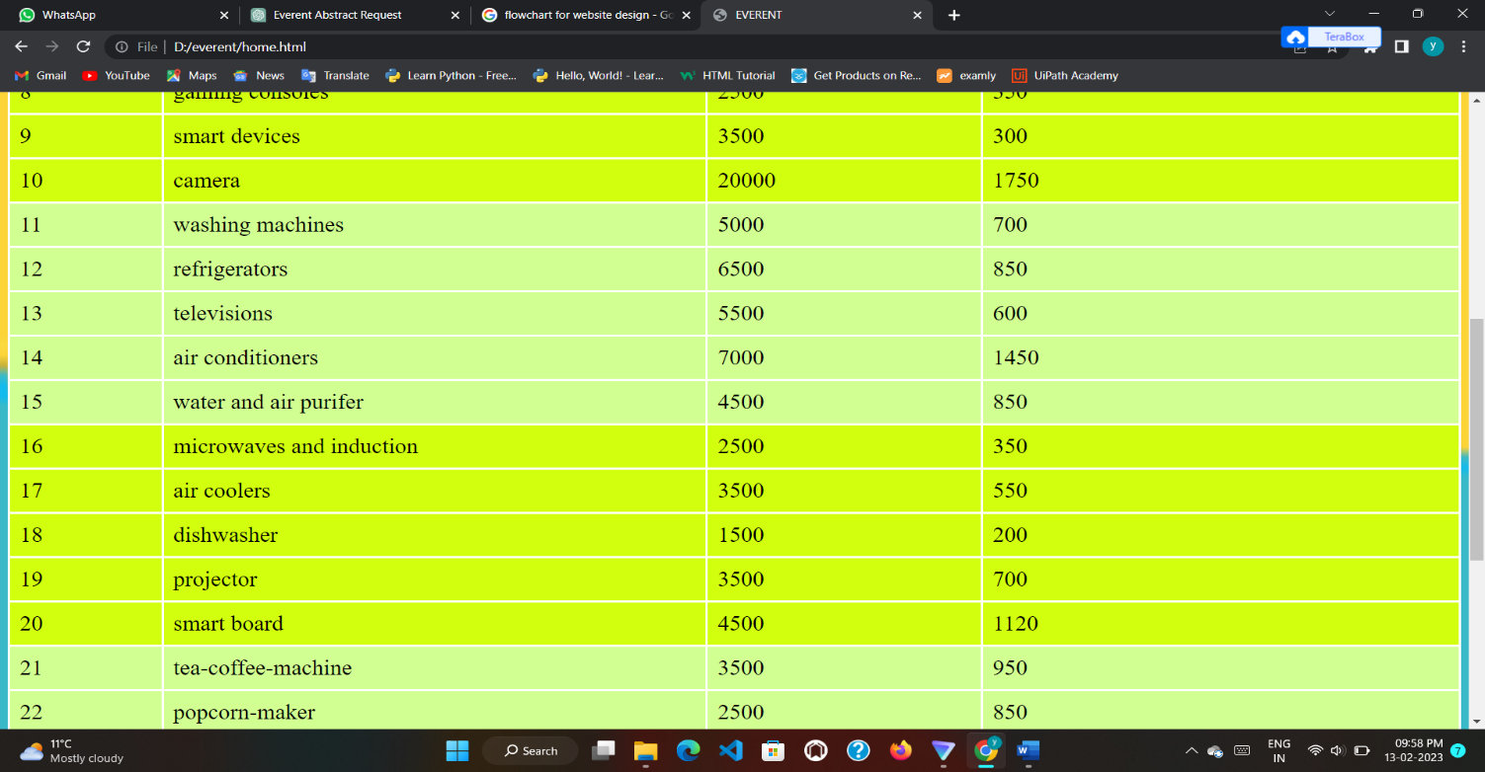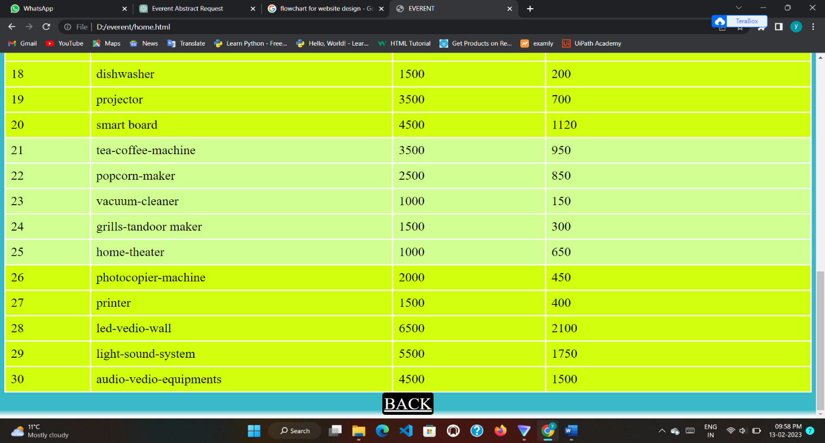

### 4.2 CATEGORIES

15

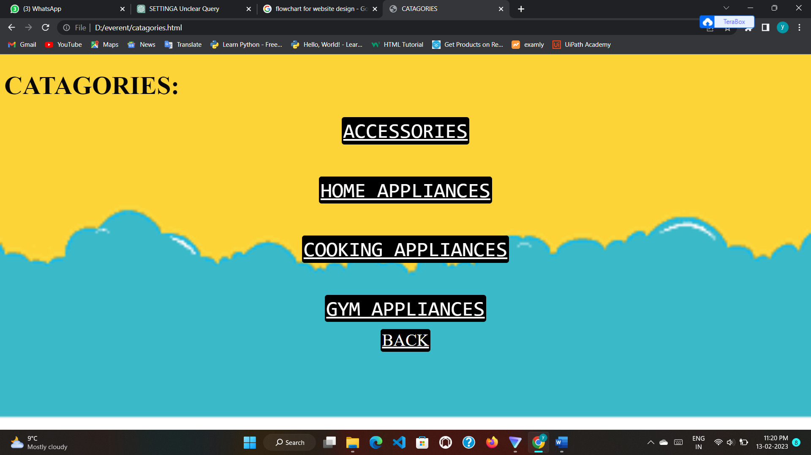

### 4.2.1 ACCESSORIES

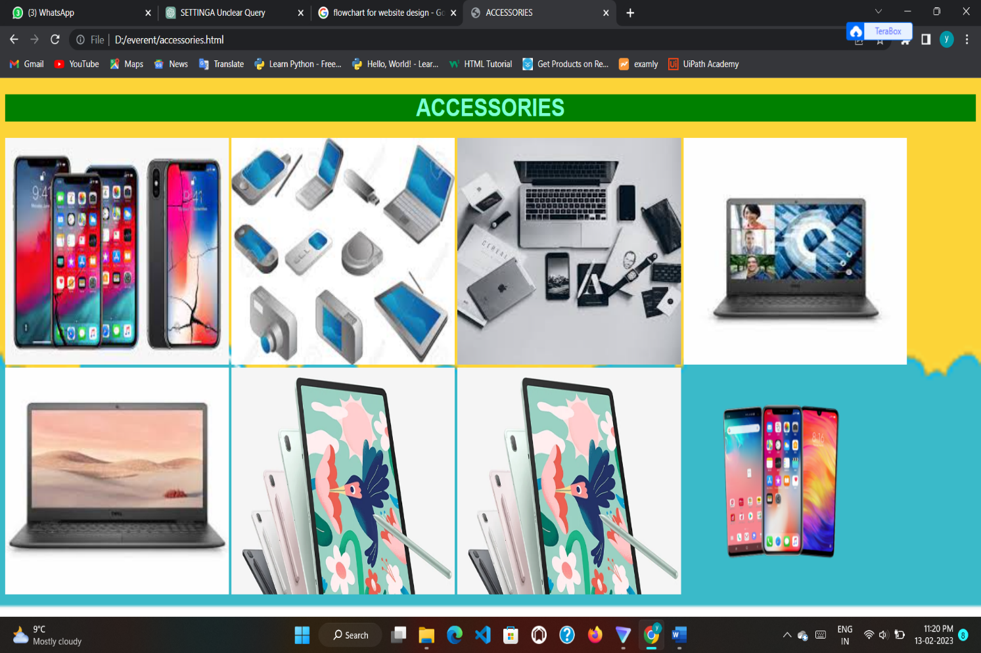

### 4.2.2 HOME APPLIANCES

16

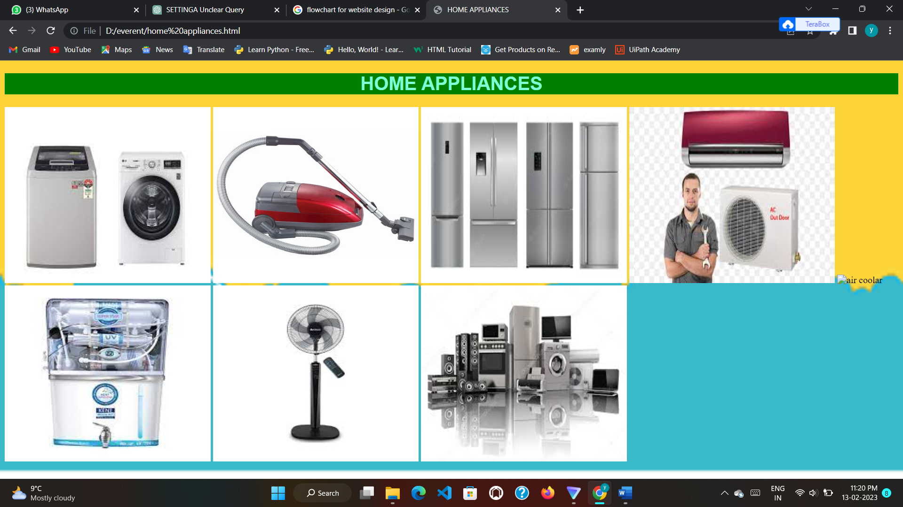

### 4.2.3 COOKING APPLIANCES

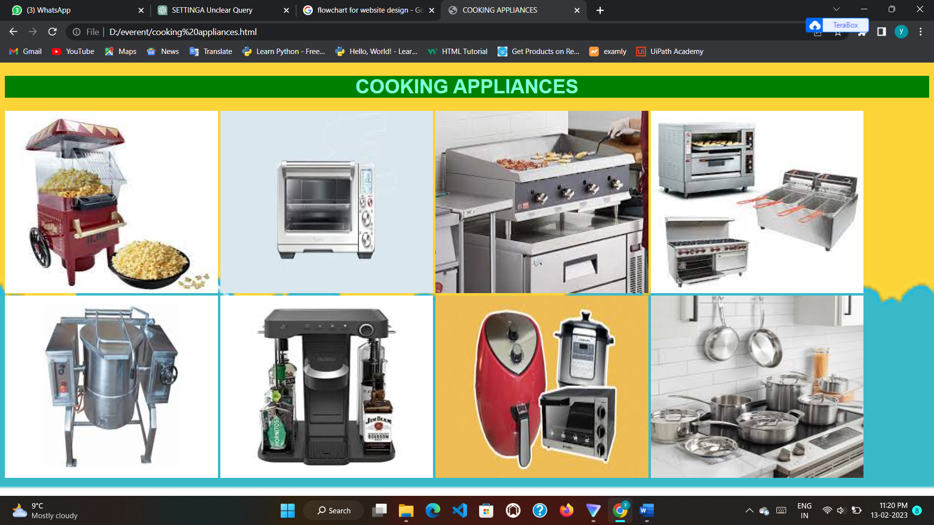

17

### 4.2.4 GYM APPLIANCES

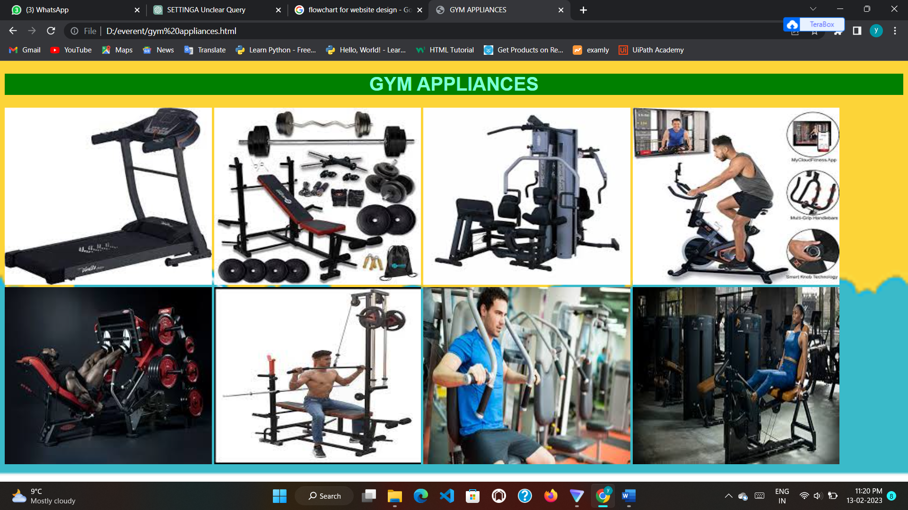

### 4.3 SIGNIN PAGE

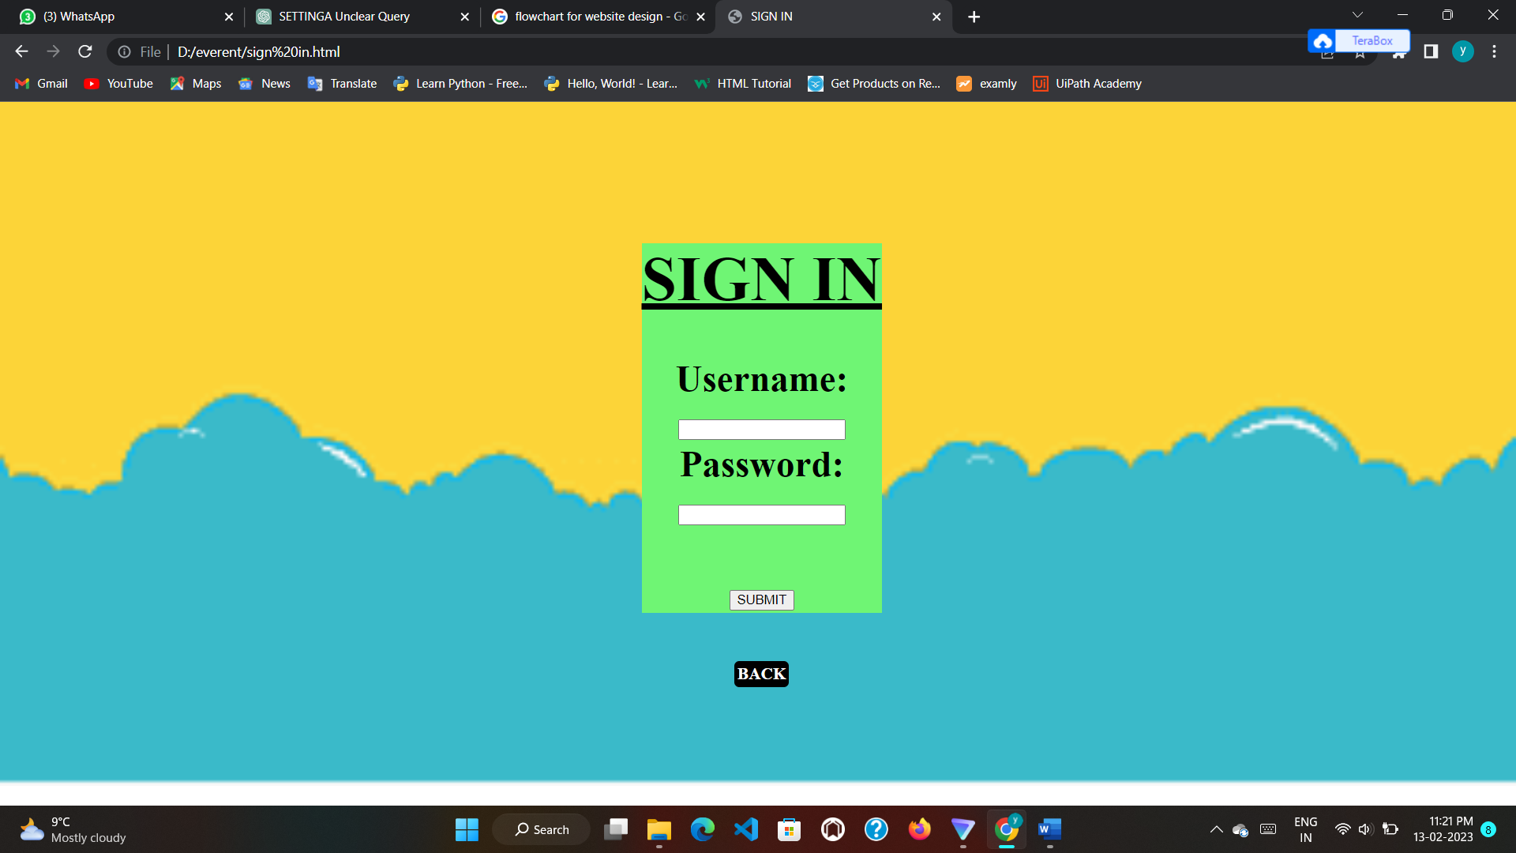

18

### 4.4 SETTINGS

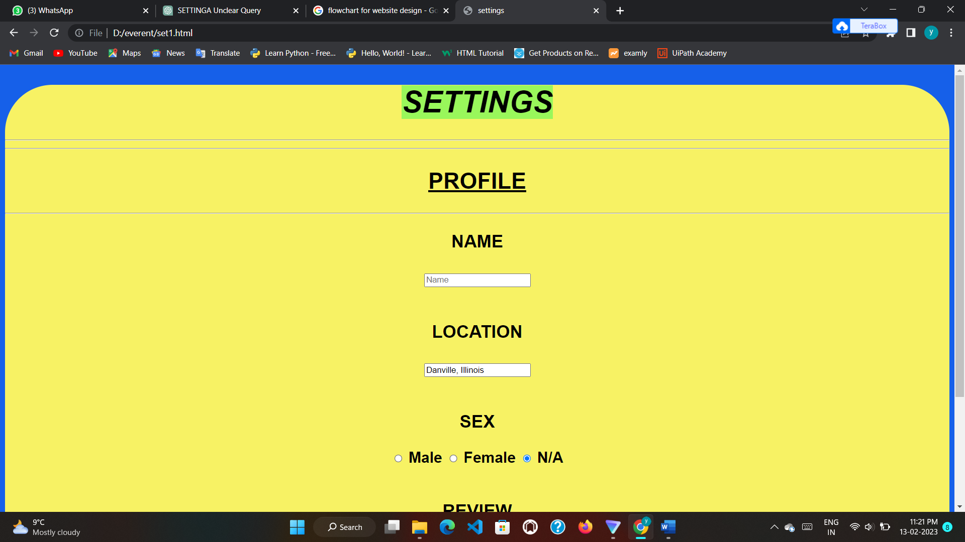

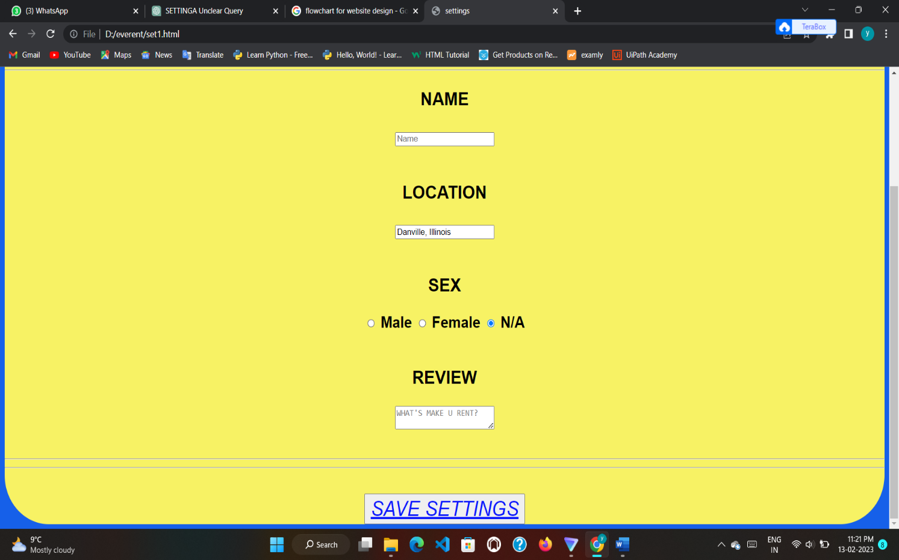

### 4.5 ABOUT

19

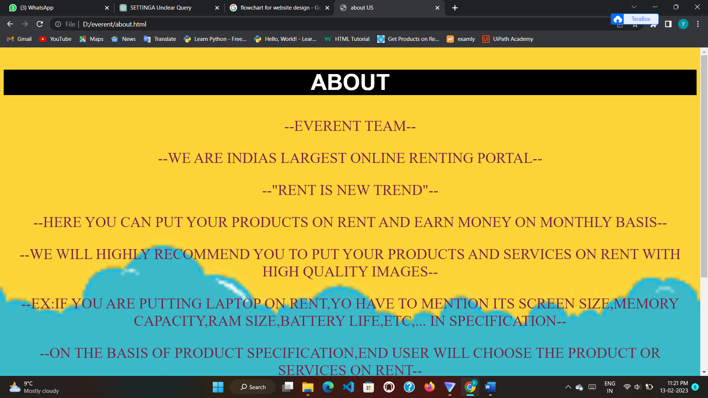

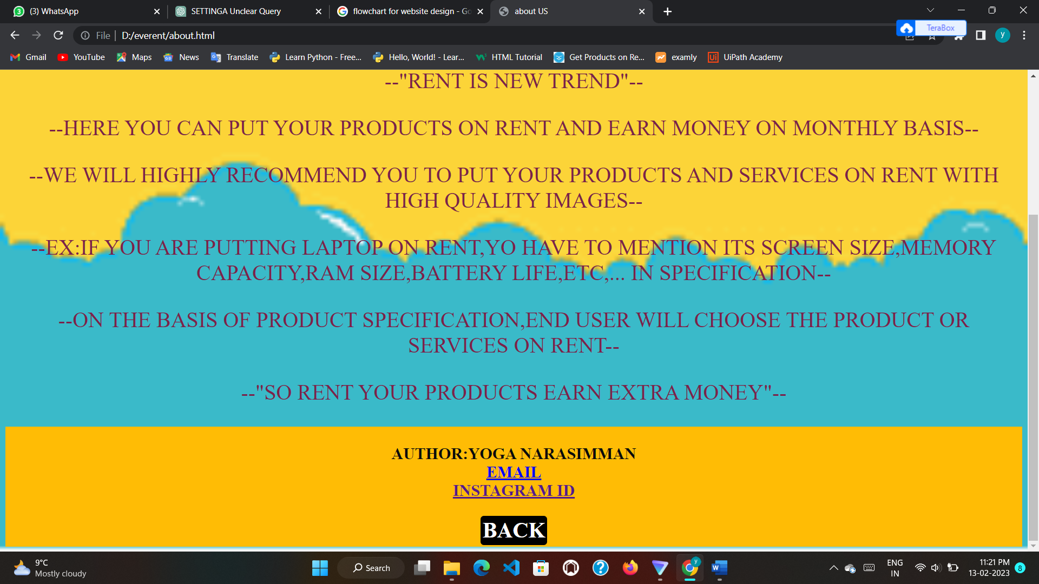

### 4.6 CODING

20

#### MAIN PAGE:

<!DOCTYPE html>

<html>

<head>

<title>EVERENT</title>

<style>

nav ul{

display: flex;

width: 100%;

margin: auto;

padding: 20px 0px;

align-items: center;

justify-content: space-between;

}

nav ul li {

display: inline-block;

margin: 10px 20px;

}

nav ul li a{

text-decoration: none;

color: rgb(255, 255, 255);

font-weight: bold;

background-color: rgb(0, 0, 0);

padding: 10px;

border-radius: 5px;

}

nav ul li a:hover{

color: rgb(72, 237, 249);

padding:20px;

}

#eg{

color: rgb(225, 255, 0);

background-color: rgb(0, 0, 0);

text-align: center;

font-size: xx-large;

padding: 20px;

border-radius: 10px;

}

img{border-radius: 150px;

}

</style>

</head>

<body style="background-image:url('bg2.png'); background-repeat: no-repeat; background-size: cover;">

<nav>

<ul>

<li><a href="home.html">HOME</a></li>

<li><a href="catagories.html">CATAGORIES</a></li>

<li><a href="sign in.html">SIGN IN</a></li>

<li><a href="set1.html">SETTINGS</a></li>

<li><a href="about.html">ABOUT US</a></li>

</ul>

</nav>

<h1><b><i><CENTER style="font-size:200%; color:rgb(254, 251, 251); font-family: Arial, Helvetica, sans-serif;background-color: rgb(0, 11, 11);"> <U>EVERENT</U> </CENTER></i></b></h1>

21

<h2><b><i><center style="font-size:100%; color:rgb(252, 245, 245); font-family:'Gill Sans', 'Gill Sans MT', Calibri, 'Trebuchet MS', sans-serif;background-color: rgb(160, 4, 4);"><U>RENT ANYTHING U DESERVE</U></center> </i></b></h2>

<center> <img src="logo.jpg" height="250" width="250" alt="logo"></center>

<h3> <p style="font-size:100%; color:rgb(3, 17, 164); font-family:system-ui, -apple-system, BlinkMacSystemFont, 'Segoe UI', Roboto, Oxygen, Ubuntu, Cantarell, 'Open Sans', 'Helvetica Neue', sans-serif;">

# only 5% rent for all items per day<br>

# we rent all electronic gadgets for affordable price<br>

# our main aim is to create all poor people to access to many costly things<br>

# for taking rent they should give any original id proof or 25% of original cost as advance payment<br>

</p> </h3>

<pre id="eg">$$$$$ ELECTRONIC GADGETS $$$$$</pre>

</body>

</html>

**HOME PAGE:**

<!DOCTYPE html>

<html>

<head>

<title>EVERENT</title>

<style>

#eg{

color: rgb(225, 255, 0);

background-color: rgb(0, 0, 0);

text-align: center;

font-size: xx-large;

padding: 20px;

border-radius: 10px;

}

.bc{

background-color: black;

padding: 30px;

display:inline-flex;

border-radius: 5px;

padding: 3px;

font-size: xx-large;

}

.bc a{

color: white;

}

.bc a:hover{

color: rgb(128, 228, 28);

}

</style>

</head>

<body style="background-image:url('bg2.png'); background-repeat: no-repeat; background-size: cover;">

<pre id="eg">$$$$$ ELECTRONIC GADGETS $$$$$</pre>

<style>

table, th, td {

border: 3px solid black;

border-collapse: collapse;

border-color: white;

padding: 10px;

}

</style>

<h1 style="color:rgb(0, 0, 0); background-color: rgb(95, 95, 255); font-weight: bold; border-radius: 20px; text-align: center; padding: 10px; ">AVAILABLE GADGETS FOR RENT</h1>

22

<table style="font-size: x-large; width:100%">

<tr style="background-color:rgb(253, 115, 115)">

<th>S.NO</th>

<th>GADGETS</th>

<th>ADVANCE</th>

<th>RENT PER MONTH</th>

</tr>

<tr style="background-color:rgb(209, 255, 145)">

<td>1</td>

<td>cross trainers</td>

<td>5000</td>

<td>750</td>

</tr>

<tr style="background-color:rgb(209, 255, 145)">

<td>2</td>

<td>treadmills</td>

<td>7000</td>

<td>1100</td>

</tr>

<tr style="background-color:rgb(209, 255, 145)">

<td>3</td>

<td>exercise bikes</td>

<td>4000</td>

<td>600</td>

</tr>

<tr style="background-color:rgb(209, 255, 145)">

<td>4</td>

<td>massagers</td>

<td>1000</td>

<td>250</td>

</tr>

<tr style="background-color:rgb(209, 255, 145)">

<td>5</td>

<td>smartphones</td>

<td>6500</td>

<td>1255</td>

</tr>

<tr style="background-color:rgb(209, 255, 14)">

<td>6</td>

<td>laptops</td>

<td>15000</td>

<td>1400</td>

</tr>

<tr style="background-color:rgb(209, 255, 14)">

<td>7</td>

<td>tablets</td>

<td>3000</td>

<td>500</td>

</tr>

<tr style="background-color:rgb(209, 255, 14)">

<td>8</td>

<td>gaming consoles</td>

<td>2500</td>

<td>350</td>

</tr>

<tr style="background-color:rgb(209, 255, 14)">

<td>9</td>

<td>smart devices</td>

<td>3500</td>

<td>300</td>

23

</tr>

<tr style="background-color:rgb(209, 255, 14)">

<td>10</td>

<td>camera</td>

<td>20000</td>

<td>1750</td>

</tr>

<tr style="background-color:rgb(209, 255, 145)">

<td>11</td>

<td>washing machines</td>

<td>5000</td>

<td>700</td>

</tr>

<tr style="background-color:rgb(209, 255, 145)">

<td>12</td>

<td>refrigerators</td>

<td>6500</td>

<td>850</td>

</tr>

<tr style="background-color:rgb(209, 255, 145)">

<td>13</td>

<td>televisions</td>

<td>5500</td>

<td>600</td>

</tr>

<tr style="background-color:rgb(209, 255, 145)">

<td>14</td>

<td>air conditioners</td>

<td>7000</td>

<td>1450</td>

</tr>

<tr style="background-color:rgb(209, 255, 145)">

<td>15</td>

<td>water and air purifer</td>

<td>4500</td>

<td>850</td>

</tr>

<tr style="background-color:rgb(209, 255, 14)">

<td>16</td>

<td>microwaves and induction</td>

<td>2500</td>

<td>350</td>

</tr>

<tr style="background-color:rgb(209, 255, 14)">

<td>17</td>

<td>air coolers</td>

<td>3500</td>

<td>550</td>

</tr>

<tr style="background-color:rgb(209, 255, 14)">

<td>18</td>

<td>dishwasher</td>

<td>1500</td>

<td>200</td>

</tr>

<tr style="background-color:rgb(209, 255, 14)">

<td>19</td>

<td>projector</td>

<td>3500</td>

<td>700</td>

</tr>

24

<tr style="background-color:rgb(209, 255, 14)">

<td>20</td>

<td>smart board</td>

<td>4500</td>

<td>1120</td>

</tr>

<tr style="background-color:rgb(209, 255, 145)">

<td>21</td>

<td>tea-coffee-machine</td>

<td>3500</td>

<td>950</td>

</tr>

<tr style="background-color:rgb(209, 255, 145)">

<td>22</td>

<td>popcorn-maker</td>

<td>2500</td>

<td>850</td>

</tr>

<tr style="background-color:rgb(209, 255, 145)">

<td>23</td>

<td>vacuum-cleaner</td>

<td>1000</td>

<td>150</td>

</tr>

<tr style="background-color:rgb(209, 255, 145)">

<td>24</td>

<td>grills-tandoor maker</td>

<td>1500</td>

<td>300</td>

</tr>

<tr style="background-color:rgb(209, 255, 145)">

<td>25</td>

<td>home-theater</td>

<td>1000</td>

<td>650</td>

</tr>

<tr style="background-color:rgb(209, 255, 14)">

<td>26</td>

<td>photocopier-machine</td>

<td>2000</td>

<td>450</td>

</tr>

<tr style="background-color:rgb(209, 255, 14)">

<td>27</td>

<td>printer</td>

<td>1500</td>

<td>400</td>

</tr>

<tr style="background-color:rgb(209, 255, 14)">

<td>28</td>

<td>led-vedio-wall</td>

<td>6500</td>

<td>2100</td>

</tr>

<tr style="background-color:rgb(209, 255, 14)">

<td>29</td>

<td>light-sound-system</td>

<td>5500</td>

<td>1750</td>

</tr>

<tr style="background-color:rgb(209, 255, 14)">

25

<td>30</td>

<td>audio-vedio-equipments</td>

<td>4500</td>

<td>1500</td>

</tr>

</table>

<center><div class="bc"><a href="everent.html">BACK</a></div></center>

</body>

</html>

**CATEGORIES PAGE:**

<!DOCTYPE html>

<html>

<head>

<title>CATAGORIES</title>

<style>

.cs{

background-color: black;

padding: 30px;

display:inline-flex;

border-radius: 5px;

padding: 3px;

font-size: xxx-large;

}

.cs a{

color: white;

}

.cs a:hover{

color: rgb(11, 245, 109);

}

.bc{

background-color: black;

padding: 30px;

display:inline-flex;

border-radius: 5px;

padding: 3px;

font-size: xx-large;

}

.bc a{

color: white;

}

.bc a:hover{

color: rgb(128, 228, 28);

}

</style>

</head>

<body style="background-image:url('bg2.png'); background-repeat: no-repeat; background-size: cover;">

<h1 style="font-size:xxx-large;font-weight:bold;color: rgb(6, 6, 6);">CATAGORIES:</h1>

<pre><center><div class="cs"><a href="accessories.html">ACCESSORIES</a></div></center>

<center><div class="cs"><a href="home appliances.html">HOME APPLIANCES</a></div></center>

<center><div class="cs"><a href="cooking appliances.html">COOKING APPLIANCES</a></div></center>

<center><div class="cs"><a href="gym appliances.html">GYM APPLIANCES</a></div></center></pre>

<center><div class="bc"><a href="everent.html">BACK</a></div></center>

</body>

</html>

**ACCESSORIES PAGE:**

26

<!DOCTYPE html>

<html>

<head>

<title>ACCESSORIES</title>

</head>

<body style="background-image:url('bg2.png'); background-repeat: no-repeat; background-size: cover;">

<h1 style="background-color: GREEN;font-size:xx-large;color:aquamarine;font-family:Arial, Helvetica, sans-serif;font-weight: bold;"><center>ACCESSORIES</center></h1>

<P >

<img src="D:\everent\images (3).jpg" alt="mobile" height="300" width="350" >

<img src="D:\everent\images (4).jpg" alt="ACCESSORIES" height="300" width="350" >

<img src="D:\everent\images (5).jpg" alt="ACCESSORIES" height="300" width="350" >

<img src="D:\everent\images (7).jpg" alt="laptop" height="300" width="350" >

<img src="D:\everent\images (8).jpg" alt="laptop" height="300" width="350" >

<img src="D:\everent\tab2.webp" alt="tab" height="300" width="350" >

<img src= "D:\everent\tab2.webp" alt="tab" height="300" width="350" >

<img src="D:\everent\Mobile-Phones-on-Rent-768x512.png" alt="mobile" height="300" width="300" > </P>

</body>

</html>

**HOME APPLIANCES:**

<!DOCTYPE html>

<html>

<head>

<title>HOME APPLIANCES</title>

</head>

<body style="background-image:url('bg2.png'); background-repeat: no-repeat; background-size: cover;">

<h1 style="background-color: GREEN;font-size:xx-large;color:aquamarine;font-family:Arial, Helvetica, sans-serif;font-weight: bold;"><center>HOME APPLIANCES</center></h1>

<P >

<img src="D:\everent\washing machine.jpg" alt="washing machine" height="300" width="350" >

<img src="D:\everent\vacuum-cleaners.webp" alt="vacuum cleaner" height="300" width="350" >

<img src="D:\everent\refrigerator.jpg" alt="refigrrator" height="300" width="350" >

<img src="D:\everent\air conditioner.jpg" alt="air conditioner" height="300" width="350" >

<img src="D:\everent\air coolar.webp.crdownload" alt="air coolar" height="300" width="350" >

<img src="D:\everent\images (13).jpg" alt="WATER FILTER" height="300" width="350" >

<img src="D:\everent\20.jfif" alt="TABLE FAN" height="300" width="350" >

<img src="D:\everent\21.jfif" alt="ACC" height="300" width="350" >

</P>

</body>

</html>

**COOKING APPLIANCES:**

<!DOCTYPE html>

<html>

<head>

<title>COOKING APPLIANCES</title>

</head>

<body style="background-image:url('bg2.png'); background-repeat: no-repeat; background-size: cover;">

<h1 style="background-color: GREEN;font-size:xx-large;color:aquamarine;font-family:Arial, Helvetica, sans-serif;font-weight: bold;"><center>COOKING APPLIANCES</center></h1>

<P >

<img src="D:\everent\images (10).jpg" alt="popcorn-maker" height="300" width="350" >

<img src="D:\everent\31.jfif" alt="OVAN" height="300" width="350" >

<img src="D:\everent\32.jfif" alt="DOSA STOVE" height="300" width="350" >

<img src="D:\everent\33.jfif" alt="INDUSTRIAL MACHINE" height="300" width="350" >

27

<img src="D:\everent\34.jfif" alt="INDUSTRIAL MACHINE" height="300" width="350" >

<img src="D:\everent\35.jfif" alt="FILTER COFFEE" height="300" width="350" >

<img src="D:\everent\36.jfif" alt="APPLIANCES" height="300" width="350" >

<img src="D:\everent\37.jfif" alt="APPLIANCES" height="300" width="350" >

</P>

</body>

</html>

**GYM APPLIANCES:**

<!DOCTYPE html>

<html>

<head>

<title>GYM APPLIANCES</title>

</head>

<body style="background-image:url('bg2.png'); background-repeat: no-repeat; background-size: cover;">

<h1 style="background-color: GREEN;font-size:xx-large;color:aquamarine;font-family:Arial, Helvetica, sans-serif;font-weight: bold;"><center>GYM APPLIANCES</center></h1>

<P>

<img src="D:\everent\22.jfif" alt="TRADEMILL" height="300" width="350" >

<img src="D:\everent\23.jfif" alt="WEIGHT LIFTING" height="300" width="350" >

<img src="D:\everent\24.jfif" alt="MULTIWORKOUT" height="300" width="350" >

<img src="D:\everent\25.jfif" alt="CYCLING" height="300" width="350" >

<img src="D:\everent\26.jfif" alt="LEG WORKOUT" height="300" width="350" >

<img src="D:\everent\27.jfif" alt="WINGS WORKOUT" height="300" width="350" >

<img src="D:\everent\28.jfif" alt="CHEST WORKOUT" height="300" width="350" >

<img src="D:\everent\29.jfif" alt="LEG WORKOUT" height="300" width="350" >

</P>

</body>

</html>

**SIGNIN PAGE:**

<!DOCTYPE html>

<html><head>

<title>SIGN IN </title>

<style>

.pos{

font-weight: bold;

font-size: xx-large;

position: absolute;

top:100px;

left:650px;

}

.bc{

background-color: black;

padding: 30px;

display:inline-flex;

border-radius: 5px;

padding: 3px;

font-size:17px;

}

.bc a{

color: white;

text-decoration: none;

}

.bc a:hover{

color: rgb(236, 253, 1);

}

28

</style>

</head>

<body style="background-image:url('bg2.png'); background-repeat: no-repeat; background-size: cover;">

<div class="pos">

<form style="background-color: rgb(111, 245, 116);">

<h1><u><CENTER>SIGN IN</CENTER></u></h1>

<CENTER><h3><form action="/action_page.php">

<label for="username">Username:</label><br>

<input type="text" id="username" name="username"><br>

<label for="pwd">Password:</label><br>

<input type="password" id="pwd" name="pwd"><br><br>

<input type="submit" value="SUBMIT">

</form></h3></CENTER>

<center><div class="bc"><a href="everent.html">BACK</a></div></center>

</form>

</div>

</body>

</html>

**SETTINGS PAGE:**

<!DOCTYPE html>

<html>

<head>

<title>settings</title>

<style>

.settings{

background-color: rgb(247, 242, 100);

text-align: center;

font-weight: bold;

font-family: Arial, Helvetica, sans-serif;

font-size: x-large;

border: 10px;

border-radius: 2cm;

border-color: rgb(2, 2, 24);

}

.BUT{

padding: 30px;

display:inline-flex;

border-radius: 5px;

padding: 3px;

font-size: xx-large;

}

.BUT a{

color: rgb(9, 21, 253);

}

.BUT a:hover{

color: rgb(17, 237, 101);

}

</style>

</head>

<body style="background-color: rgb(22, 96, 233);">

<main class="settings">

<form>

<h1><i class="ST" style="background-color: rgb(153, 247, 91);">SETTINGS</i></h1>

<HR>

<HR>

</div>

<div class="panel profile">

29

<h2><i class="ST"></i><U>PROFILE</U></h2><HR>

<label for="name" class="text-label"><h3>NAME</h3></label>

<input type="text" id="name"placeholder="Name"><br><br>

<label for="location" class="text-label"><H3> LOCATION</H3></label>

<input type="text" id="location" placeholder="Location" value="Danville, Illinois"><br><br>

<label><H3>SEX</H3></label>

<div class="select">

<input type="radio" name="sex" id="male"> <label for="male">Male</label>

<input type="radio" name="sex" id="female"> <label for="female">Female</label>

<input type="radio" name="sex" id="na" checked="checked"> <label for="na">N/A</label>

</div>

<BR>

<label for="bio"><H3>REVIEW</H3></label>

<textarea name="bio" id="bio" placeholder="WHAT'S MAKE U RENT?"></textarea>

</div>

<br><HR><HR><br>

<button type="submit" class="material-button">

<i class="BUT"><a href="everent.html">SAVE SETTINGS</a></i>

</button>

</form>

</main>

</body>

</html>

**ABOUT:**

<!DOCTYPE html>

<html>

<head>

<title>about US</title>

<style>

.para{

font-size: xx-large;

color: rgb(123, 34, 74);

}

footer{

text-align: center;

padding: 2px;

background-color: rgb(255, 188, 5);

color: rgb(10, 12, 12);

font-size: x-large;

font-weight: bold;

}

.bc{

background-color: black;

padding: 30px;

display:inline-flex;

border-radius: 5px;

padding: 3px;

font-size: xx-large;

}

.bc a{

color: white;

text-decoration: none;

}

.bc a:hover{

color: rgb(128, 228, 28);

}

</style>

30

</head>

<body style="background-image:url('bg2.png'); background-repeat: no-repeat; background-size: cover;" >

<h1><center><p style="background-color: black;color: white;font-size: xxx-large;font-family: Arial, Helvetica, sans-serif;">ABOUT</p></center></h1>

<div class="para">

<p><center>--EVERENT TEAM--</center></p>

<P><CENTER>--WE ARE INDIAS LARGEST ONLINE RENTING PORTAL--</CENTER></P>

<P><CENTER>--"RENT IS NEW TREND"--</CENTER></P>

<P><CENTER>--HERE YOU CAN PUT YOUR PRODUCTS ON RENT AND EARN MONEY ON MONTHLY BASIS--</CENTER></P>

<P><CENTER>--WE WILL HIGHLY RECOMMEND YOU TO PUT YOUR PRODUCTS AND SERVICES ON RENT WITH HIGH QUALITY IMAGES--</CENTER></P>

<P><CENTER>--EX:IF YOU ARE PUTTING LAPTOP ON RENT,YO HAVE TO MENTION ITS SCREEN SIZE,MEMORY CAPACITY,RAM SIZE,BATTERY LIFE,ETC,... IN SPECIFICATION--</CENTER></P>

<P><CENTER>--ON THE BASIS OF PRODUCT SPECIFICATION,END USER WILL CHOOSE THE PRODUCT OR SERVICES ON RENT--</CENTER></P>

<P><CENTER>--"SO RENT YOUR PRODUCTS EARN EXTRA MONEY"-- </CENTER></P></div>

<footer>

<p>AUTHOR:YOGA NARASIMMAN<BR>

<a href="mailto:yoganarasimman3311@gmail.com">EMAIL<br>

<a href="https://instagram.com/_y_0_g_a?igshid=YmMyMTA2M2Y=">INSTAGRAM ID</a></p>

<center><div class="bc"><a href="everent.html">BACK</a></div></center>

</footer>

</body>

</html>

## CHAPTER 5 CONCLUSION

31

This chapter tells about the conclusion that anyone can drive from the project and the learning I learnt by taking over this project.

### CONCLUSION

Everent is a web-based platform that connects property owners with prospective renters. The website allows property owners to list their properties for rent and enables renters to search for available properties. Everent offers a user-friendly interface, excellent customer service, and a secure platform for transactions. In this conclusion, I will discuss the strengths and weaknesses of the platform and provide recommendations for improvement.

Overall, Everent is a reliable platform that provides an excellent service to both renters and property owners. The website's user-friendly interface, excellent customer service, and secure platform make it a popular choice among users. However, the platform could benefit from expanding its geographic coverage, adding property management features, and improving its marketing options. If Everent can address these areas of improvement, it has the potential to become a dominant player in the rental market.

### FUTURE SCOPE

As a renting website, Everent has the potential for significant growth and success in the future. The continued rise of the sharing economy, coupled with increasing demand for sustainable and affordable living solutions, makes the rental market an attractive and viable business.

One of the key advantages of Everent is its ability to cater to a wide range of rental needs, from short-term rentals for travelers to long-term leases for residents. This flexibility, combined with a user-friendly platform, could make Everent a popular choice among renters and property owners alike.

To stay competitive in the rental market, Everent could focus on expanding its offerings to include a wider variety of properties and locations, as well as implementing additional features such as virtual property tours and streamlined payment options. By building a strong reputation for reliability and customer satisfaction, Everent could also attract repeat business and word-of-mouth referrals.

32

As technology continues to advance, Everent could explore the use of artificial intelligence and machine learning to enhance its rental matching algorithms and improve the user experience. Additionally, partnerships with other businesses and organizations could help Everent reach new audiences and expand its services.

Overall, the future for Everent looks promising, provided the company continues to adapt and innovate to meet the evolving needs of the rental market.

### REFERENCES

1 GeeksforGeeks, “Types of E-commerce”, <https://www.geeksforgeeks.org/types-of-e-commerce/>

2. W3Schools-For HTML, CSS & JS (<https://www.w3schools.com/>)

3. Gurol-Urganci, I., de Jongh, T., Vodopivec-Jamsek, V., Atun, R., & Car, J. (2013). Mobile phone messaging reminders for attendance at healthcare appointments. The Cochrane Database of Systematic Reviews, (12), CD007458. https://doi.org/10.1002/14651858.CD007458.pub3 Li, Z. (2013).